85.01.17
From Mordecai Cooke
RB MSS M86B, Library, Royal Botanic Gardens Melbourne.

Australian Fungi -1884
Drawings returned of—
 |  | Stereum elegans Fr | Blue Mountains
22 |  | Tremella mesenterica Fr | Gippsland | Tisdall
22 |  | Geaster floriformis Vitt |  | Do
18 |  | Tremella albida Huds |  | Do
25 |  | Schizophyllum commune Fr |  | Do
21 |  | Peziza vesiculosa Fr |  | Do
16 |  | Agaricus (Mycena) galericulatus Fr |  | Do
24 |  | Agaricus (Mycena) polygrammus Fr |  | Do
17 |  | Chlorosplenium aeruginosum Tul |  | Do
26 |  | Peziza apiculata Cooke |  | Do
19 |  | Agaricus (Lepiola) clypeolarius Fr |  | Do
23 |  | Polyporus (Anodermei) opiculiferus Cke |  | Do
 |  | Clavaria amethystina Fr | Mount Wellington
12 |  | Baeomyces sp (a Lichen) | Gippsland | Tisdall
15 |  | Agaricus (Leptonia)? |  | Do
14 |  | Agaricus indeterminable |  | Do
11 |  | Panus sp, or Cantharellus sp, |  | Do
10 |  | Looks like a Marasmius |  | Do
9 |  | Either Peziza or Dacrymyces (no fruit) |  | Do
13 |  | Agaricus (section uncertain) |  | Do
8 |  | Agaricus (Mycena) galericulatus Fr | Stringers Creek
5 |  | Lycoperdon sp?
2 |  | Russula citrina Gil (? if acrid)
6 |  | probably Polyporus spumeus Fr
1 | ｝ | Indeterminable
7 | ｝ | Indeterminable
13 |  | Agaricus (Armillaria) sp
4 |  | Agaricus (Collybia) xanthopus Fr affinis
3 |  | Agaricus (Pholiota) radicosus Fr?

Specimens
25 | Peziza vesiculosa Fr |  |  |  |  | Guntawang Hamilton
 | Polyporus Tricholoma Mont |  |  |  |  | Endeavour River
22 | Polyporus (Anodermei) Weinmanni Fr |  |  |  |  | N Gipps Land
18 | Do |  |  |  | Do | Do
 | Do |  |  |  | Do | Mount Napier V
4 | Hexagona decipiens Berk |  |  |  |  | Moonan Brook NSW
 | Polyporus pelliculosus Berk |  |  |  |  | Mount Napier
 | Polyporus (Ano) fragilis Fr |  |  |  |  | Gipps Land
 | Polyporus (Ano) spiculiferus Cke |  |  |  |  | Gipps Land |  |  |  |  |  |  | Webb
23 | Do |  |  | Do |  | N Gipps Land |  |  |  |  |  |  | Teesdall
 | Polyporus rubiginosus Berk |  |  |  |  | Clarence River
 | Polyporus (Res) atrovinosus Cke |  |  |  |  | Mt Napier
 | Badhamia sp too much crushed for identification |  |  |  |  | Sydney |  |  |  |  |  |  | Miss Scott
 | Agaricus (Trich) brevipes Bull |  |  |  |  | Barossa Range
 | Scleroderma geaster Fr |  |  |  |  | near Melbourne
 | Polyporus grammocephalus B |  |  |  |  | Mossman River
 | Grandinia australis B |  |  |  |  | Gipps Land
 | Polyporus xanthopus Fr |  |  |  |  | Mossman River
 | Polyporus flabelliformis Fr |  |  |  |  | Do
1 | Acidium & |  | ｝ | lagenophorae Cke |  | Omeo
1 | Puccinia |  | ｝
2 | Puccinia malvacearum [C..a] |  |  |  |  | Do
3 | Uredo bulbines Kalch |  |  |  |  | Do
5 | Nectria ferruginea Cke |  |  |  |  | Do
6 | Ustilago digitariae Rabh |  |  |  |  | Do
7 | Sterile spots |  |  |  |  | Do
8 | ｝ | no fungus found |  |  |  | Do
9
10 | Asteroma Rosae Fr |  |  |  |  | Do
11 | Imperfect Septoria (no fruit) |  |  |  |  | Do
12 | Cyathus sp. too young to name the species |  |  |  |  | Do
14 | larvae of insect |  |  |  |  | Do
 | Coccus on Acacia verticillata |  |  |  |  | Gipps Land
 | Dictyonema membranaceum Ag
 | Morchella conica Pers
G | Polyporus ochroleucus B |  |  |  |  | Omeo
B | Ileodictyon gracile B |  |  |  |  | Omeo
 | Claviceps purpurea Tul (Ergot) |  |  |  |  | West Victoria
J | Peziza apiculata Cke |  |  |  |  | Omeo
21 | Polyporus oblectans B |  |  |  |  | Do
N | Polysaccum pisocarpium |  |  |  |  | Do
 | Polyporus membranaceus Fr (? Young) |  |  |  |  | Shoalhaven
D | Scleroderma vulgare Fr |  |  |  |  | Omeo
 | Geaster australis B |  |  |  |  | St Vincents |  |  |  |  |  |  | Tepper
M | Stereum elegans Fr |  |  |  |  | Omeo
I | Agaricus (Pleur) candescens Mull |  |  |  |  | Do
 | Agaricus (Coll) fusipes Bull? |  |  |  |  | Do
10 | Agaricus (Arm) melleus Vahl |  |  |  |  | Do
A | Agaricus (Hypholoma) fasicularis Fr |  |  |  |  | Do
 | Hydnum clavarioides B & C var |  |  |  |  | Richmond River |  |  |  |  | Hodgkinson
 | Agaricus (Nauc) centunculus Fr |  |  |  |  |  |  |  |  |  | Do
 | Agaricus (Pleur) Tasmanicus B |  |  |  |  |  |  |  |  |  | Do
 | Polyporus (Ino) elongatus B |  |  |  |  | Richmond River
 | Marasmius Mülleri B |  |  |  |  | Do
 | Agaricus (Flam) picreus Fr |  |  |  |  | Do
 | Agaricus (Galera) tener Fr |  |  |  |  | Do
 | Agaricus (Lepiota) Beckleri B |  |  |  |  | Do
 | Cladoderris dendritica P |  |  |  |  | Do
 | Polyporus annosus Fr |  |  |  |  | Do
 | Hydnum ochraceum Fr |  |  |  |  | Do
 | Geaster fimbriatus Fr |  |  |  |  | Do
 | Polyporus (Res) obducens Fr |  |  |  |  | Do
 | Schizophyllum commune Fr |  |  |  |  | Lockyer Creek Q
 | Lentinus fasciatus Fr |  |  |  |  | Do
 | Geaster fimbriatus Fr |  |  |  |  | Urara River
 | Polyporus rhipidium B |  |  |  |  | Richmond River
 | Marasmius calopus Fr |  |  |  |  | Do
 | Clavaria stricta Fr |  |  |  |  | Urara River NSW
 | Stereum lobatum Kze |  |  |  |  | Norfolk Island
 | Hirneola polytricha |  |  |  |  | Do
 | Polyporus cinnabarinus Fr |  |  |  |  | Do
 | Mylitta australis B |  |  |  |  | W. Port Phillip
 | Clavaria botrylis P |  |  |  |  | Wildwood V
 | Hirneola polytricha |  |  |  |  | Severn
 | Tremella mesenterica Fr |  |  |  |  | Swan River Sewell
 | Cladoderris dendritica P |  |  |  |  | Shoalhaven NSW
 | Polyporus rhipidium B |  |  |  |  | Richmond River
4 | Clavaria stricta Fr |  |  |  |  | Apsley River Crawford
 | Clavaria flava Fr |  |  |  |  | Swan River Sewell
 | Clavaria inaequalis Fr |  |  |  |  | Brogers Creek NSW
 | Collema (nigrescens?) Lichen |  |  |  |  | Severn Hartmann
 | Cyathus fimicola B |  |  |  |  | Wimmera River
 | Stemonitis fusca R |  |  |  |  | Mount Lofty SA
602 | Polyporus Laestadii B |  |  |  |  | Shoalhaven NSW
 | Marasmius calopus Fr |  |  |  |  | Richmond River Mrs H
 | Marasmius androsaceus Fr |  |  |  |  | Do
 | Marasmius Mülleri B |  |  |  |  | Severn Hartmann
 | Lentinus Lecomtei Fr (minor) |  |  |  |  | Swan River Sewell
 | Agaricus (Trich) sulphureus Fr |  |  |  |  | Do
 | Agaricus (Lepiota) procerus Fr |  |  |  |  | Do
 | Polyporus campyles B |  |  |  |  | Port Phillip
27 | Hydnum cirrhatum Fr |  |  |  |  | Gipps Land
37 | Aecidium bellidis DC var Brachycomis |  |  |  |  | Omeo
39 | Aecidium Prenanthis L. v. microceres |  |  |  |  | Do
35 | Uredo (perhaps new) on plant unknown |  |  |  |  | Do
 | On Correa speciosa – produced by insects
36 | Uredo cichoracearum DC |  |  |  |  | Do
 | Uromyces microtidis Cke |  |  |  |  | Bulladulah NSW
 | Puccinia malvacearum Corda  Aecidium ranunculacearum DC |  |  |  |  | nr Melbourne  Guntawang
2 | Uredo lini DC |  |  |  |  | Guntawang
3 | Puccinia malvacearum [M] |  |  |  |  | Do
4 | Puccinia hieracii Mart |  |  |  |  | Do
5 | Uredo prenanthis v. microseres |  |  |  |  | Do
6 | Uredo compositarum v Podolepidis |  |  |  |  | Do
7 | Puccinia hieracii Mart on Crepis |  |  |  |  | Do
8 | Aecidium plantaginis |  |  |  |  | Do
9 | Uredo unguillariae Cke |  |  |  |  | Do
10 | Uredo bulbipipes Kalch |  |  |  |  | Do
38 | Exolete |  |  |  |  | Omeo
29 | Penicillium candidum Lk |  |  |  |  | Walhalla
 | Xylostroma giganteum |  |  |  |  | Mt Dromedary
 | Ustilago carbo Tul |  |  |  |  | Thistle Island
 | Morchella conica P |  |  |  |  | Kangaroo Island
 | Polyporus lucidus Fr |  |  |  |  | Bloomfield River
 | Polyporus elongatus B |  |  |  |  | Do
7 | Polyporus oblectans B |  |  |  |  | N Shore Sydney
2 | Ozonium aureum |  |  |  |  | Sydney Whitelegge
21 | Polyporus oblectans B |  |  |  |  | Omeo
 | Schizophyllum commune Fr |  |  |  |  | Torvoomba
105 | Irpex flavus Kl |  |  |  |  | Clyde River
 | Mylitta australis B |  |  |  |  | Port Jackson
 | Mylitta australis B |  |  |  |  | Torvoomba
 | Hexagona Wightii B |  |  |  |  | Do
22 | Lycoperdon caelatum Fr |  |  |  |  | Omeo
15 | Stereum elegans Fr |  |  |  |  | Do
17 | Ag (Lepiota) procerus Fr |  |  |  |  | Omeo
19 | Ag (Psal) campestris Fr |  |  |  |  | Do
1 | Lachnocladium flagelliforme B |  |  |  |  | Double Bay
88 | Polyporus australis Fr |  |  |  |  | Norfolk Island
309 | Xylaria gigas Cke |  |  |  |  | Richmond River
 | Xylaria gigas Cke |  |  |  |  | Bloomfield River
M C Cooke
17 Jan. 1885.

Acacia verticillata
Acidium lagenophorae
Aecidium bellidis var Brachycomis
Aecidium plantaginis
Aecidium Prenanthis var microceres
Aecidium ranunculacearum
Agaricus (Lepiota) procerus
Agaricus (Psalliota) campestris
Agaricus (Armillaria) melleus
Agaricus (Collybia) fusipes
Agaricus (Collybia) xanthopus
Agaricus (Flammula) picreus
Agaricus (Galera) tener
Agaricus (Hypholoma) fasicularis
Agaricus (Lepiola) clypeolarius
Agaricus (Lepiota) Beckleri
Agaricus (Lepiota) procerus
Agaricus (Leptonia)
Agaricus (Mycena) galericulatus
Agaricus (Mycena) polygrammus
Agaricus (Naucoria) centunculus
Agaricus (Pholiota) radicosus
Agaricus (Pleurotus) candescens
Agaricus (Pleurotus) Tasmanicus
Agaricus (Tricholoma) brevipes
Asteroma Rosae
Badhamia
Baeomyces
Cantharellus
Chlorosplenium aeruginosum
Cladoderris dendritica
Cladoderris dendritica
Clavaria amethystina
Clavaria botrylis
Clavaria flava
Clavaria inaequalis
Clavaria stricta
Clavaria stricta
Claviceps purpurea
Collema nigrescens
Crepis
Cyathus
Cyathus fimicola
Dacrymyces
Dictyonema membranaceum
Geaster australis
Geaster fimbriatus
Geaster floriformis
Grandinia australis
Hexagona decipiens
Hexagona Wightii
Hirneola polytricha
Hydnum cirrhatum
Hydnum clavarioides
Hydnum ochraceum
Ileodictyon gracile
Irpex flavus
Lachnocladium flagelliforme
Lentinus fasciatus
Lentinus Lecomtei
Lycoperdon caelatum
Marasmius androsaceus
Marasmius calopus
Marasmius Mülleri
Morchella conica
Mylitta australis
Nectria ferruginea
Ozonium aureum
Panus
Penicillium candidum
Peziza apiculate
Peziza vesiculosa
Polyporus (Anodermei) fragilis
Polyporus (Anodermei) opiculiferus
Polyporus (Anodermei) spiculiferus
Polyporus (Anodermei) Weinmanni
Polyporus (Inodermei) elongatus
Polyporus (Resupinatus) atrovinosus
Polyporus (Resupinatus) obducens
Polyporus annosus
Polyporus australis
Polyporus campyles
Polyporus cinnabarinus
Polyporus elongatus
Polyporus flabelliformis
Polyporus grammocephalus
Polyporus Laestadii
Polyporus lucidus
Polyporus membranaceus
Polyporus oblectans
Polyporus ochroleucus
Polyporus pelliculosus
Polyporus rhipidium
Polyporus rubiginosus
Polyporus spumeus
Polyporus Tricholoma
Polyporus xanthopus
Polysaccum pisocarpium
Puccinia hieracia
Puccinia lagenophorae
Puccinia malvacearum
Russula citrina
Schizophyllum commune
Scleroderma geaster
Scleroderma vulgare
Septoria
Stemonitis fusca
Stereum elegans
Stereum elegans
Stereum lobatum
Tremella albida
Tremella mesenterica
Uredo bulbines
Uredo bulbipipes
Uredo cichoracearum
Uredo compositarum var Podolepidis
Uredo lini
Uredo prenanthis var microseres
Uredo unguillariae
Uromyces microtidis
Ustilago carbo
Ustilago digitariae
Xylaria gigas
Xylostroma giganteum

The list is one of a number sent by Cooke that are now in the library of the Royal Botanic Gardens Melbourne. This list comprises one folio of four pages, plus one additional page carrying the valediction and date. The four-page folio has been annotated by J. H. Willis as being part of the list that includes the date, and there are matching pin holes in the sheets. Cooke has evidently added ✓ marks against many entries, as they are in ink that has the same appearance as that in the text. The few cases where entries have been marked with a pencilled 'X' may be M's annotations, but this is difficult to confirm. Cooke's author attributions do not always coincide with those used in Cooke (1892); he has evidently use 'Fr' where the name is included in Fries (1874), which is frequently cited together with the author in Cooke (1892). Where the author attribution does not match that given in FNI or Index mycorum, this is indicated in the notes. Not all of these species are currently recognised as being Australian: May (1890), p. 268, points out that a 'tendency to place Australian collections under European species has consequently meant that a large number of European species (over 500) have been recorded from Australia'. Names have therefore been checked in Index fungorum if they are not present in FNI. FNI does not list purely infrageneric taxa, so where these are used they have been checked in Cooke (1892) or other sources identified in the notes. Names of places are identified only at their first appearance in the list; names of people are identified only when there is possibility of confusion with others mentioned in the correspondence. FNI and Index fungorum were accessed 14 May 2021.
There is a ✓ to the left of this and the next twelve lines.
NSW.
FNI gives Retzius, not Fries, as the author of the name.
Vic.
In FNI and Index fungorum as Geastrum florifiorme.
In addition to the ✓ there is a pencilled X against this line. Index fungorum attributes this name to Bulliard, although it lists some varieties named by Fries.
FNI gives Scopoli, not Fries, as the author of the name.
Index fungorum gives Bulliard, not Fries, as the author of the name. In addition to the ✓ there is a pencilled X against this line.
In addition to the ✓ there is a pencilled X against this line.
FNI gives Bulliard, not Fries, as the author of the name.
Name not found in FNI, Index fungorum, Cooke (1892) or Cooke (1892a). In addition to the ✓ there is a pencilled X against this line.
FNI gives Bulliard, not Fries, as the author of the name. In addition to the ✓ there is a pencilled X against this line.
Mt Wellington, Tas; see M to T. Stephens, August 1884 (in this edition as 84-08-00d).
Almost certainly at Walhalla, Vic. FNI gives Scopoli, not Fries, as the author of the name. There is a ✓ at the left of the line, and against 'Stringers Creek'.
Do deleted.
There is a pencilled X at the left of the line. See May (1990), p. 267, for a discussion of the difficulty of attributing species names without adequate notes of their characteristics.
FNI gives Bulliard, not Fries, as the author of the name. The text ends before the end of the page, with a squiggle under the last number in the list.
Text begins the second page of the folded folio. Unless otherwise noted all entries in this section have a ✓ at the left of the line.
Index fungorum attributes this name to Bulliard, although it lists some varieties named by Fries.
Grazing property near Gulgong, NSW.
Almost certainly Alexander Hamilton.
Qld.
In addition to the ✓, there is a pencilled X at the left of the line; FNI does not list purely infrageneric taxa, but see Fries (1836-8), p. 452. It is not listed in Index fungorum (accessed 22 April 2021), but this combination is used in Peck (1877), p. 37; Anodermei is used as an infrageneric in other combinations, for example in Berkeley & Broome (1887), pp. 218-9.
Grampians, Vic.
Hexagonia?
In addition to the ✓, there is a pencilled X at the left of the line; Ano= Anodermei.
In addition to the ✓, there is a pencilled X at the left of the line; Ano= Anodermei.
Not identified.
Tisdall.
NSW.
In addition to the ✓, there is a pencilled X at the left of the line; Res = Resupinatus; see Cooke (1881-3), vol. 10, p. 56 (although Cooke described it without that infrageneric name in Cooke (1881-3), vol. 10, p. 131).
There is no ✓ against this line. Both Harriet and Helena Scott sent specimens to M; the only fungus attributed to one of them listed on AVH (accessed 24 April 2021), MEL 1054029, is labelled "Miss Scott". After her marriage in 1864, Helena's specimens are recorded under he married name of 'Mrs Forde', and it is probable that the specimens sent to Cooke will have been collected by Harriet.
SA. In addition to the ✓, there is a pencilled X at the left of the line; Trich = Tricholoma.
North Qld.
FNI gives Klozsch, not Fries, as the author of the name.
Vic. In addition to the ✓, there is a pencilled X at the left of the line.
The author cited in Cooke (1892), p. 338, is Montagne.
Not in FNI or Index fungorum; in Cooke (1892), p. 409, the name is given as a synonym of Uromyces bulbinis. In addition to the ✓, there is a pencilled X at the left of the line.
In addition to the ✓, there is a pencilled X at the left of the line.
In addition to the ✓, there is a pencilled X at the left of the line.
In addition to the ✓, there is a pencilled X at the left of the line.
In addition to the ✓, there is a pencilled X at the left of the line.
There is no ✓ against this line.
In addition to the ✓, there is a pencilled X at the left of the line
NSW. There is no ✓ against this line.
FNI gives Hornemann, not Fries, as the author of the name, although Index fungorum has one variety named by Fries.
i.e., the St. Vincent Gulf coast of the Yorke Peninsula, SA, where Tepper was based at the time.
In addition to the ✓ at the left of this line, there is also one at the right. Pleur = Pleurotus (see Cooke (1892), p. 22).
There is no ✓ against this line. Coll = Collybia (see Cooke (1892), p. 18).
In addition to the ✓ at the left of this line, there is also one at the right. Arm = Armillaria (see Cooke (1892), p. 11).
FNI gives Hudson, not Fries, as the author of the name. In addition to the ✓ at the left of this line, there is also one at the right.
NSW.
In addition to the ✓, there is a pencilled X at the left of the line. 'Hodgkinson' is interlined and the ditto marks in the next two entries may refer only to 'Richmond River'.
In addition to the ✓ at the left of this line, there is also one at the right. Nauc = Naucoria (see Cooke (1892), p. 53).
In addition to the ✓ at the left of this line, there is also one at the right. Although: Cooke (1892), pp. 111-127 does not use infrageneric names in Polyporus, Berkeley & Broome (1887), p. 218, use the infrageneric name Pleuropus for another species.
Although Cooke (1892), pp. 111-127 does not use infrageneric names in Polyporus, Berkeley & Broome (1887), p. 219, use the infrageneric name Inodermei for another species.
In addition to the ✓ at the left of this line, there is also one at the right. Flam = Flammula (see Cooke (1892), p. 52).
In addition to the ✓ at the left of this line, there is also one at the right.
In addition to the ✓ at the left of this line, there is also one at the right.
FNI gives Persoon, not Fries, as the author of the name.
In addition to the ✓, there is a pencilled X at the left of the line. Index fungorum gives Persoon, not Fries, as the author of the name. Although Cooke (1892), pp. 111-127 does not use infrageneric names in Polyporus, Berkeley & Broome (1887), use the infrageneric name Resupinati for another species.
Qld.
FNI gives Berkeley, not Fries, as the author of the name.
Earlier name of Orara River, NSW.
FNI gives Persoon, not Fries, as the author of the name.
Then an independent British colony in the Pacific Ocean c.1400 km east of Australia, with the Governor of NSW as Governor; now an external territory of Australia.
Near Sunbury, Vic.
Probably the Severn River, Northern Tablelands, NSW.
FNI gives Retzius, not Fries, as the author of the name. There was more than one Sewell collecting for M in the Swan River region in WA, sometimes designated in the collections as 'Miss Sewell'; see Maroske & Vaughan (2014).
NSW; Alexander Crawford. FNI gives Persoon, not Fries, as the author of the name.
FNI gives Schaeffer, not Fries, as the author of the name.
FNI gives O. F. Müller, not Fries, as the author of the name. Near Shoalhaven, NSW.
Almost certainly Carl Hartmann.
Vic.
Almost certainly Mary Hodgkinson; see Maroske & Vaughan (2014).
FNI gives Bulliard, not Fries, as the author of the name. In addition to the ✓, there is a pencilled X at the left of the line, and an additional at the right; Trich = Tricholoma.
Cooke has added '(unique")' to the left of the line; FNI gives Scopoli, not Fries, as the author of the name. There is an additional ✓ to the right of the line.
FNI gives Persoon, not Fries, as the author of the name. In addition to the ✓, there is a pencilled X at the left of the line.
Error for brachycomes? In addition to the ✓, there is a pencilled X at the left of the line.
Prenanthis over compositarum deleted. In addition to the ✓, there is a pencilled X at the left of the line.
There is no ✓ to the left of this line.
Cooke (1885a), p. 12, uses this spelling; on modern maps as Bulahdelah.
FNI gives Bertero, not Fries, as the author of the name.
The remainder of the entries are on a single foolscap sheet.
Text unclear, but probable 'M', for Montagne.
Variety name not in Index fungorum (accessed 28 April 2021).
Variety name not in Index fungorum (accessed 28 April 2021).
Error for U. anguillariae? See Cooke (1892), p. 343.
Name not found in Index fungorum (accessed 28 April 2021).
Presumably in the sense of 'rancid' or 'withered', see OED. There is no ✓ to the left of this line.
Tisdall's painting of this species is included here as an example of the material supplied to Cooke. 85-01-17_image01.jpg (Painting at MEL). 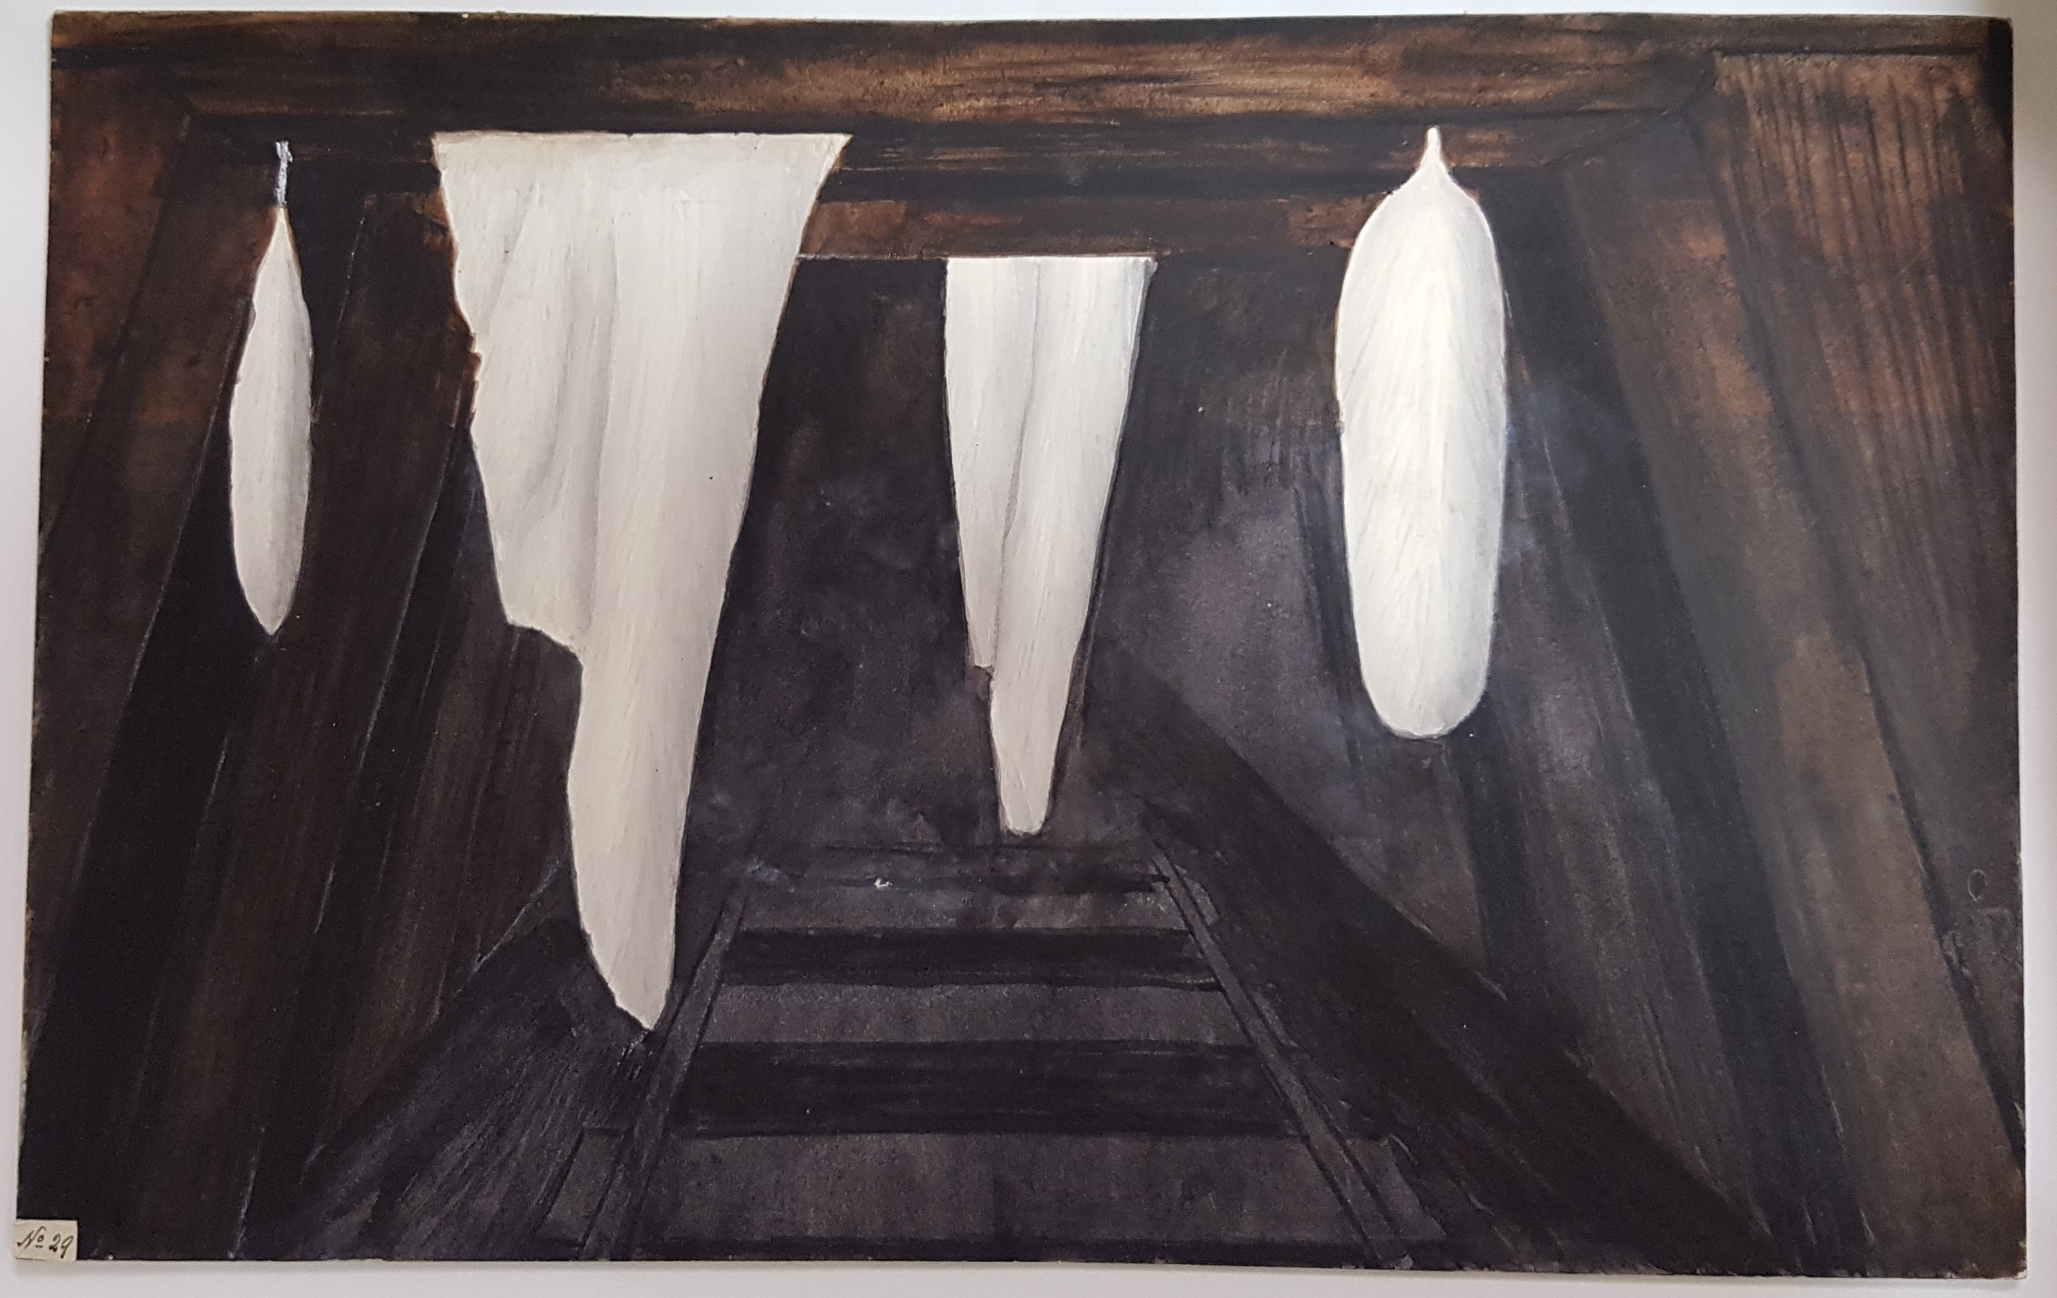 The reverse of the painting has the following text: 85-01-17_image02.jpg By M: Walhalla, Gippsland, Mr Tisdale (sic). 1883. By Tisdall: Mining tunnel By Cooke: Surface covered with Penicillium candidum Lk 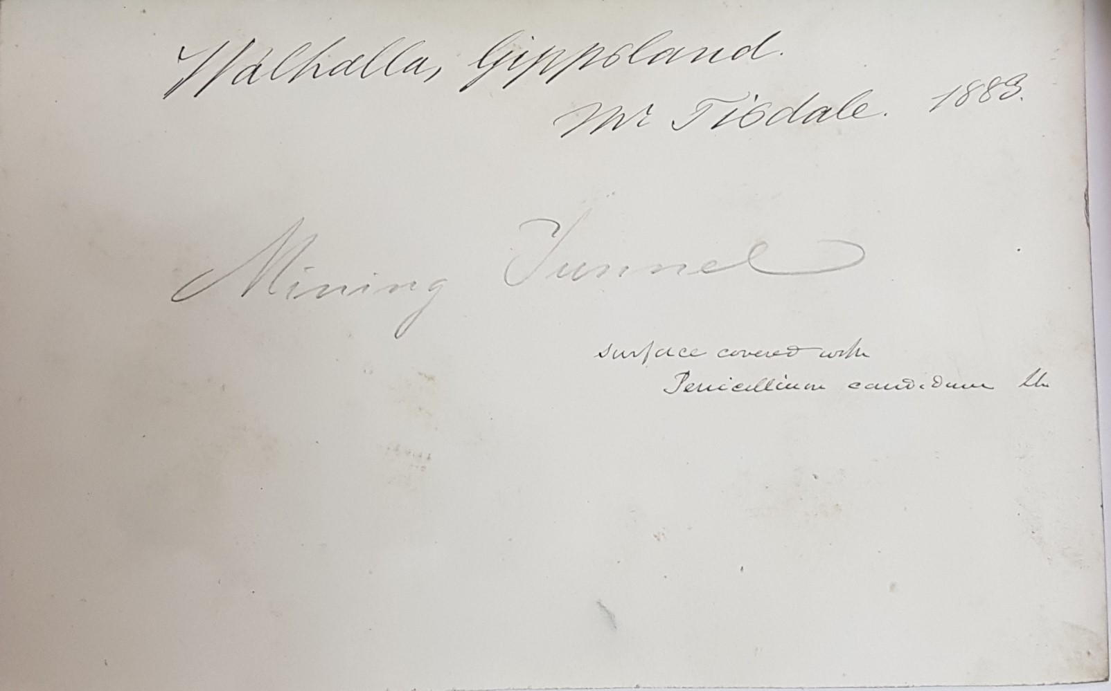
There is more than one Mt Dromedary in Australia, one in each of Tas. and Qld, and two in NSW. The specimen is likely to have come from the locality in the south-east of NSW near Tilba Tilba, where Edward Reader is known to have collected for M, see E. Reader to M, 18 March 1880, and B81.02.02.
SA?
SA.
North Qld.
Thomas Whitelegge.
Toowoomba, Qld?
NSW.
NSW.
Hexagonia wightii? FNI gives Fries as the author of the name.
FNI gives Bulliard, not Fries, as the author of the name.
Agaricus; FNI gives Scopoli, not Fries as the author of the name.
Agaricus (Psalliota) campestris. For infrageneric name, see Cooke (1892), p. 60; FNI gives Linnaeus, not Fries, as the author of the name.
NSW.

